District Camp Craft Competition 2019 – Entry Form

Please return this page by Sunday 14th April 2019
to depdc@blacktoftbeacon-scouts.org.uk

Section: | Please delete as appropriate:  Cubs Scouts
Team Name:
Number in Team:

Entry fees should be sent once confirmation of your booking has been received and this will secure your team's place.
£7.50 per Cub Team – Teams of up to 6 Cubs.
£20 per Scout Team – Teams of 4 – 6 Scouts.
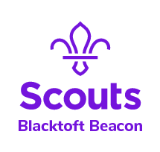
Sections can enter more than one Team, places will be allocated on a first come first served basis.

